Dissertation Submitted for the partial fulfillment of the **M.Sc. (Integrated) Five Years Program AIML/Data Science** degree to the Department of AIML & Data Science.

**M.Sc. Project Dissertation**

**Drive Insights**

submitted to



By

**Yatrik Shah**

**Semester- VIII**

**M.Sc. (Integrated) Five Years Program AIML**

Department of AIML & Data Science

School of Emerging Science and Technology

Gujarat University

**April 2023**

**DECLARATION**

This is to certify that the project work reported in this dissertation entitled “**Drive Insights**” for the partial fulfilment of Master of Science in Artificial Intelligence and Machine Learning degree is the result of investigation done by myself.

|  |  |
| --- | --- |
| Place: Ahmedabad | Yatrik Shah |
| Date: |  |

**Acknowledgement**

I would like to express my sincere gratitude to Dr. Ravi Gor, the Head of the Department, for providing me with the necessary resources and facilities to complete my project.

I extend my heartfelt thanks to my mentor, Madam Rashmi Pandey for their guidance, motivation, and valuable feedback that helped me to stay on track throughout the project.

I would like to acknowledge the efforts of the administrative staff for their constant support.

Finally, I would like to thank my friends and family for their constant encouragement and support that helped me to overcome the challenges faced during the project.

Contents

1. Abstract & Key Words 6

1.1 Abstract 7

1.2 Key Words 7

2. Introduction 8

3. Basic Terminology 10

4. Data Description 12

5. Methodology 15

5.1 Data Collection 16

5.2 Data Pre-processing 16

5.2.1 Resizing 17

5.2.2 Rescale 17

5.3 Vehicle Classification: 18

5.4 Model Building For Number Plate Detection 19

5.4.1 Custom CNN model from scratch: 19

5.4.2 YoloV5 22

5.5 Model Training 22

5.6 Number Plate Recognition: 23

5.7 Driver Details Collection: 25

5.8 Database 26

5.9 Multiple User System: 26

5.10 Real Time System 27

5.11 building Frontend and API with Flask 28

5.12 Glimpse of API 28

6. Result and Discussion 30

6.1 Loss Metrics 31

6.2 Accuracy & Loss Evaluation 32

7. Configuration 34

8. Deployment 36

9. References 37

**Chapter**

# Abstract & Key Words

## 1.1 Abstract

Computer vision is a field of study focused on the problem of helping computers to see. At an abstract level, the goal of computer vision problems is to use the observed image data to infer something about the world.

In huge systems of vehicle control like traffic management on highways or traffic management in big events and at highway tolls gathering information of the vehicles which were involved, by their number plates manually is very difficult so, AI can solve this problem using advanced computer vision algorithms.

Automatic Number Plate Detection and recognition is a technology that uses optical character recognition on images to read vehicle registration plates / number plates.

## 1.2 Key Words

End-to-end deep learning

Vehicle recognition

Number plate detection and recognition

Visitor management

Security enhancement

**Chapter**

# Introduction

Drive Insights aims to streamline visitor management and enhance security at residential and corporate buildings through the use of computer vision and natural language processing techniques.

The app provides a range of functionalities, such as vehicle detection, license plate recognition, driver identification, and visitor information collection. These features make it possible to efficiently manage visitor traffic and generate useful insights and reports for building management.

**Chapter**

# Basic Terminology

**Image Resizing**- Resizing allows you to make your image smaller or larger without cutting anything out. Resizing alters the image's dimensions, which typically affects the file size and image quality. The most common reason for resizing photos is to reduce the size of large files to make them easier to email or share online.

**Convolutional Neural Network-** Within Deep Learning, a Convolutional Neural Network or CNN is a type of artificial neural network, which is widely used for image/object recognition and classification. Deep Learning thus recognizes objects in an image by using a CNN.

**Image Dimensions-** Image dimension refers to the width and height of an image, measured in pixels.

**YOLO-** You Only Look Once

**OCR** - Optical Character Recognition

**Chapter**

# Data Description

Here the dataset is containing two directories. Out of which one is containing images, and another is containing annotations of the respective images.

Here the word Annotations refers to the details of the bounding box of the object that is present in the image like: class, bounding box coordinates i.e., x minimum, x maximum, y minimum, y maximum.

The images in the data can be in different shapes. So, they are reshaped in the dimensions (640 * 640 * 3). And the Annotations are also scaled respectively.

Images are in different file formats like: .jpg, .jpeg, .png. And Annotations are stored in Extensible Markup Language (.xml).

The dataset is collected from [Kaggle](https://www.kaggle.com/datasets/andrewmvd/car-plate-detection). As well as some numbers of images are also collected manually. And also, the respective Annotations including the bounding box, in order to get some real-life images which basically contains noise.

The main goal to perform this step is to add some more noise in data and create more generalized and robust model.

**Chapter**

# Methodology

## Data Collection

Data collection is always considered as the first step of every typical machine learning or Deep Learning project.

Quality and size of data is one of the most important key points in every model performance.

As mentioned in the Data Description, the data is collected from Kaggle. In addition, some of the dataset is also collected manually from various sources and Annotated manually.

## Data Pre-processing

Basically, collected data is in the row format. Not pre-processed at all. Providing this raw data directly to the model is always not advisable.

It may fluctuate of decrease the quality of model performance.

### Resizing

Image resizing is a process in image processing that involves scaling an image to a desired size. This can be done by either increasing or decreasing the size of the image. It is typically used to reduce the file size of an image or to fit an image into a certain frame size.

For model training, we have to give same size images to the model. So as per the individual image size we would have to either upscale it or downscale it.

Here the chosen image size is ( 640* 640 ).

### Rescale

Image rescaling is a process of changing the size of an image. It is typically used to resize images to fit a certain size or resolution, or to reduce the physical size of an image file. It is also used to reduce the number of colors in an image, or to change the aspect ratio of an image.

Here Image Resizing is done by scaling image pixel values from 0 to 1. It is similar to MinMaxScaler in sklearn.

It is achieved by dividing all the pixel values by 255.

## Vehicle Classification:

Here Vehicle Classification model, takes part.

For vehicle classification here CNN ( Convolutional Neural Network ) is used.

In CNN, VGG16 architecture model is built and trained over the dataset.

Here dataset includes three major classes:

1. Two – Wheeler
2. Four – Wheeler
3. Auto Rikshaw

Here also some important steps are performed for model training such as :

1. Data Collection
2. Data Pre – processing
3. Data Exploration and Analysis
4. Model Building
5. Model Selection
6. Model Training
7. Model Export

## Model Building For Number Plate Detection

Here two type of CNN models are used.

1. Custom CNN model from scratch
2. YoloV5

### Custom CNN model from scratch:

Convolutional Neural Networks (CNNs) are a type of neural network architecture that is typically used for solving computer vision tasks. The architecture of a CNN consists of an input layer, which is the raw pixel data of an image, followed by several convolutional layers, which perform convolution operations on the input image.

* Convolution Operation:

Convolution is a key operation in convolutional neural networks (CNNs). It is a mathematical operation that takes two inputs, one is a matrix of image pixels and the other is a matrix of weights or kernels, and produces a new matrix of outputs. In CNNs, convolutional layers apply a convolution operation to the input, passing the result through an activation function and then pooling the result into the next layer. This process allows the neural network to learn features from the input images and extract features from them. Convolutional layers are essential for image classification, as they enable the network to identify patterns in the input images.

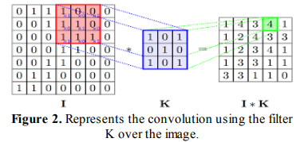

* Max Pooling:

Max pooling is a technique used in convolutional neural networks (CNNs) for reducing the size of an input, or for extracting features from an input. It works by selecting the maximum value from a region of the input, typically a 2x2 or 3x3 region. This reduces the dimensionality of the input, allowing the neural network to better focus on the most important features in the input. Max pooling also helps to prevent overfitting, as it reduces the number of parameters that the network needs to learn.

* Batch normalization Layer:

Batch normalization is a technique used to normalize the inputs of each layer in a neural network to have a mean of 0 and unit variance, which helps the network to learn faster and generalize better.

* Flatten layer:

Flattening a layer in one line involves combining all the layers of a model into a single layer, usually the output layer, so that the output of the model is a single, flat vector.

* Dropout Layer:

Dropout is a regularization technique used in neural networks, where a proportion of nodes are randomly excluded from the network during training to reduce overfitting.

### YoloV5

YOLO (You Only Look Once) is a state-of-the-art, real-time object detection system. Yolo has the capability to dominant all the others algorithms.

It is a convolutional neural network (CNN) based model that is able to detect objects in an image or video by using a single neural network. YOLO divides a given image into a grid of 13×13 cells and each of these cells is responsible for predicting 5 bounding boxes. Each bounding box consists of 5 attributes: (x, y) coordinates of the center of the box, the width and height of the box, and the confidence score of having an object in that box. In addition, the model also predicts the class probability for each box. YOLO is fast and accurate compared to other object detection models.

## Model Training

In model building step only the model architecture is built.

Now we have to train the data to the model.

Before model training we would perform data augmentation.

* Data Augmentation

Data augmentation is a process used to increase the amount and diversity of data available for training in machine learning and deep learning tasks. It is a form of regularization that allows machine learning models to generalize better to unseen data. Data augmentation is typically used when the amount of training data is limited, or when the data is imbalanced. It can also be used to introduce additional variability into the training dataset and help prevent over-fitting. Data augmentation techniques include adding noise to the data, randomly flipping or rotating images, randomly cropping images, and using data augmentation algorithms such as GANs (Generative Adversarial Networks).

## Number Plate Recognition:

Number Plate Recognition (NPR) is a technology that uses optical character recognition (OCR) to automatically read the license plates on vehicles.

It involves capturing an image of a vehicle's license plate using a camera and then processing that image to extract the alphanumeric characters from the plate.

Where, The OCR technology is used to extract the text from the captured number plate image and then convert it into machine-readable characters.

The OCR technology used in this application is based on deep learning models such as Convolutional Neural Networks (CNN) and Recurrent Neural Networks (RNN).

These models are trained on large datasets of images and characters to identify and extract text accurately from the number plates.

The OCR technology used in this project has several advantages, such as high accuracy and efficiency. It allows for automatic and real-time recognition of number plates, eliminating the need for manual intervention.

Here a pre-defined python library `eacy-ocr` is used for OCR purpose.

## Driver Details Collection:

This step involves the Driver / Rider details collection.

The app includes the database, which can include some important information like :

* Driver / Rider name,
* Destination : where he / she want to go [ Shop number / House number]
* Phone Number: phone number of the driver / rider
* Purpose of visit
* Time / Date [automatically]

These all information are to be inserted in the application User Interface.

These information can be very helpful regarding the security concerns.

## Database

Here the Prediction database is maintained, Prediction database refers to the database where the predicted numberplate data is stored.

Here SQLite is chosen as the database. It is a lightweight database we can use along with python.

From the API we also can retrieve / download the data in the form of CSV file. And also we can Reset session. Where Reset Session refers to delete all the records from the database table.

Here the final output database contains the information :

Sr no., Number plate , Vehicle Type, Driver Name, Phone number, purpose of visit, current time.

## Multiple User System:

Multiple User System is a feature of a web application that enables multiple users to access and use the system simultaneously.

It is particularly useful in scenarios where multiple users need to interact with the system at the same time or where user-specific data needs to be managed separately.

In the case of an ML end-to-end web application like the one being discussed, Multiple User System would enable building management to grant access to different users, such as security personnel and receptionists, who can use the system to manage visitors and access useful data. Each user would have their own login credentials, and their actions within the system would be tracked and monitored separately.

So here “**Signup**” and “**Login**” pages and functions as well as respective backend python logic and scripts are developed, to manage multiple users and to isolate the database logically.

## Real Time System

This application supports real time camera.

Such that, we can capture the vehicle photo in real time.

To achieve this, python library opencv-python is used.

## building Frontend and API with Flask

An End-to-end project is always incomplete without Frontend and API. Here as a frontend, a Web Application is built with HTML and CSS. Flask is used as a python framework – API.

## Glimpse of API

**Chapter**

# Result and Discussion

## Loss Metrics

Object Detection is basically a Regression problem so here the chosen loss metrics is Mean Squared Error.

Since Regression output is the four edges of the object, the error is mean squared distance between original and predicted bounding box edges, x min, x max, y min, y max respectively.

## 6.2 Accuracy & Loss Evaluation

Training Accuracy

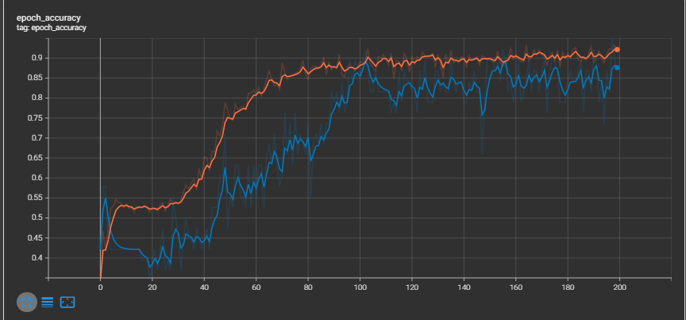

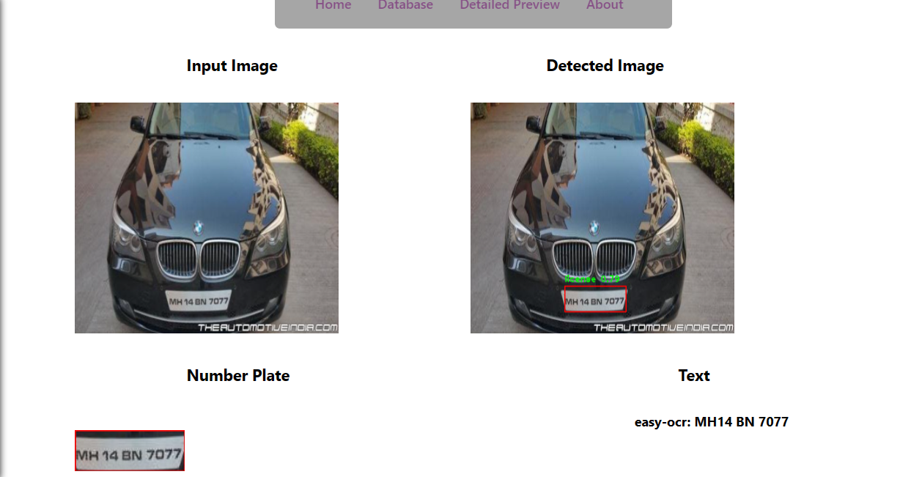

**Chapter**

# Configuration

**For Host:**

**Software:**

python = 3.10.4

numpy

panda

tensorflow > 2.0

opencv-python = 4.5.4

torch = 1.13.0 + cpu

matplotlib

easyocr = 1.6.2

pytesseract = 0.3.10

flask = 2.1.3

flask_cors = 3.0.10

HTML5 + CSS

**Hardware:**

A CPPU and processor with latest 4GB of RAM and two processors.

Further depend upon the hardware, as much better the hardware, the faster the processes execute.

For user:

A phone with internet access and camera.

**Chapter**

# Deployment

Currently it is running on local host.

**Chapter**

# References

<https://www.google.com/>

<https://www.wikipedia.org/>

<https://www.analyticsvidhya.com/>

<https://towardsdatascience.com/>